Locating Ourselves: Geographically & Socially

Introduction
At Xwi7xwa Library we are often asked how people can learn more about the traditional territories they occupy. Typically patrons are interested in how they can ensure their research and work is relevant to the places they are currently living. In ones process of learning about a specific community or nation they usually encounter knowledges and teachings that are specific to a given nation.
Sometimes these resources are made for the general public and come directly from the community/nation (for example a nation’s site). In other instances the information one finds may come from a third party and was not originally intended for the general public (this can be common in historical accounts of Indigenous peoples told from someone outside the community/nation).
While there are many avenues to learning about a community or nation it is imperative that readers think critically about where the information is coming from (authorship and authority) as well as how one will integrate and mobilize what they have learned in their research. An individual learner’s work is bound up in who they are, what they have authority to speak about, and who they are accountable to. While there are many ways to learn about and understand perspectives that are not our own, these knowledges and teachings may not belong to us as researchers and therefore need to be used responsibly within our work.
The point of this document is to give readers a very basic understanding of traditional territory, how to find out whose territory one is on, and how integrating community/nation knowledge is based off a person’s responsibility and accountability to these places. The goal is for readers to think about:
- who they are
- where they come from (where their ancestors are from)
- how they have come to be in specific locations today
- their relationship to other peoples and lands based off the above factors

What is traditional territory?
Traditional territory refers to the lands and waters occupied by Indigenous peoples since time immemorial. In Canada, some traditional territories have been ceded through the treaty process while other lands remain unceded (land never surrendered through treaty or war).

How do I find out whose traditional territory I am on?
The easiest way to gain an initial understanding of whose territory you are on is to:
- Visit Native-Land.ca
- Search your location (either by city or postal code)
- Explore the community sites provided by the site
Note: The information on this site is not perfect but rather a starting place that will lead you to a community or nation site.
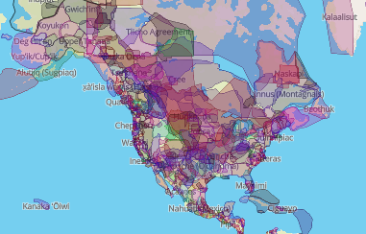
Retrieved from: native-land.ca

What is a territorial acknowledgement and why do we do them?
“A land acknowledgement (or territorial acknowledgement) is considered a respectful, yet political, statement that acknowledges the colonial context of the Indigenous territory/territories where a gathering is taking place. It recognizes relationships between land and people, and in particular Indigenous peoples' continued presence on the lands being acknowledged.” https://guides.library.ubc.ca/c.php?g=715538&p=5109932

Why does any of this matter?
As the UBC community responds to national events like the Truth and Reconciliation Commission of Canada and the 94 Calls to Action professors have reoriented their assignments to include relevancy to Indigenous topics. As a result our library has experienced an increase in patron requests to make their projects relevant to the lands on which their research is taking place.
As previously mentioned, how one responsibly incorporates the knowledge they encounter is interwoven with identity. For example an Ojibway researcher on Musqueam territory would not share information that does not belong to them about the community and that is not on a public resource (for example the Musqueam website).
“Location as an Aboriginal research methodology is one way to ensure that researchers of Aboriginal peoples and Aboriginal knowledge are connected with and accountable to the Aboriginal community” (Brown, 2005, p. 118).

Locating ourselves:
Knowing where one is geographically located is only one piece to grounding a person’s research and ensuring it is relevant to place. Another piece is who the researcher is, where they come from (heritage), and how this connects person to place; this is what some scholars refer to as “locating ourselves” (Brown, 2005). Brown states that “location is more than simply saying you are of Cree or Anishinabe or British ancestry; from Toronto or Alberta or Canada; location is about relationships to land, language, spiritual, cosmological, political, economical, environmental, and social elements in one’s life” 2005, p. 98). These factors influence our individual perspectives as researchers and from an Indigenous worldview it “is about being congruent with a knowledge system that that tells us that we can only interpret the world from the place of our experience (Kovach, 2005, p. 110).”

Guiding Questions
From Brown, Leslie A. (2005). Research as resistance: critical, indigenous and anti-oppressive approaches. p. 264-266:
- Who is involved in shaping the topic [of your research]?
  - Who determined the topic and why?
  - Has an instructor requested it? Why?
  - Is it developed by participants and, if so, why?
  - Who says this is a question that needs to be studies anyway?
- Is an agency requesting the research?
  - If so, what are their reasons, explicit and implicit, for doing so?
  - Is there funding available for certain topics? Is it to justify future funding?
- Is it for reflecting on practice in order to change processes?
  - Is an issue “hot” because it is a topical in the newspaper?
  - Is it to rationalize actions already committed to?

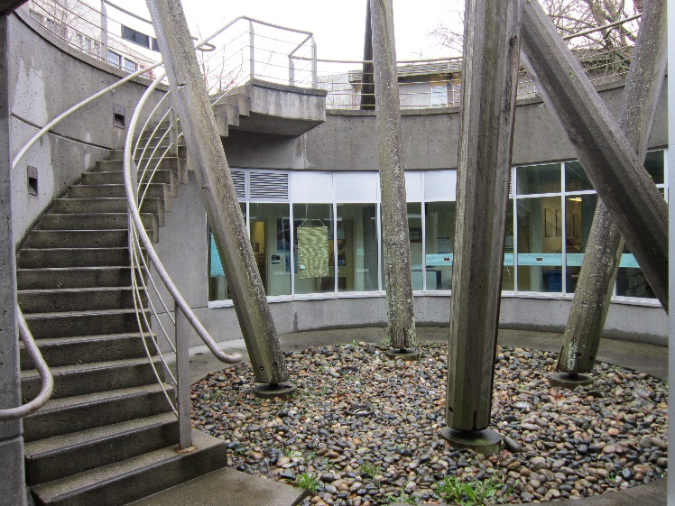

Resources
Alcoff, L. (1988). Cultural feminism versus post-structuralism: The identity crisis in feminist theory. Signs: Journal of Women in Culture and Society, 13(3), 405-436. doi:10.1086/494426

Walton, R., Moore, K.R., & Jones, N.N. (2019). Positionality (1st ed., pp, 63-82) Routledge. doi:10.4324/9780429198748-4.

Xwi7xwa Library (2020). Xwi7xwa - Distance Research: doing land acknowledgements. UBC Library. https://students.ubc.ca/ubclife/what-land-acknowledgement

References
Brown, Leslie A. (2005). Research as resistance: critical, indigenous and anti-oppressive approaches [eBook edition] (Strega, Susan, Ed.). Toronto: Canadian Scholars’ Press. http://ezproxy.library.ubc.ca/login?url=http://search.ebscohost.com/login.aspx?direct=true&db=nlebk&AN=145914&site=ehost-live&scope=site

Kovach, Margaret. (2009). Indigenous methodologies: characteristics, conversations, and contexts. Toronto: University of Toronto Press.

